Post-operative free tissue transfer monitoring protocols in the reconstruction of head and neck defects in UK Oral and Maxillofacial Surgery units.
BAOMS Student Bursary Project 2021/2022
Anna Davies

Post-operative free tissue transfer monitoring protocols in the reconstruction of head and neck defects in UK Oral and Maxillofacial Surgery units.

Background:
Free tissue transfers are often utilised for reconstruction of defects in head and neck surgery. Selection of the type of bony/soft tissue flaps varies between different surgical units based on several key factors including type of defect, patient co-morbidities, scans as well as surgical training and surgeon preference.

Failure of free flaps is reported to be in the region of 2-5% ¹⁻³and is associated with significant patient morbidity, increased hospital stays and limitations in further reconstructive options⁴. It is therefore crucial that arterial or venous compromise of a free tissue transfer is identified early, to hopefully allow flap salvage⁵. As such close clinical monitoring and the use of Doppler’s is undertaken in the post-operative period for patients who have undergone free tissue transfer.

A previous survey conducted nearly 15 years ago found there to be wide variations in the post-operative observations of free tissue transfer⁶. Frequent observations are labour intensive for those undertaking them and can be felt by patients to be disruptive in the early stages of their recovery.

Aim:
To undertake a survey of Oral and Maxillofacial Surgery (OMFS) units across the UK undertaking free tissue transfers to reconstruct defects in the head and neck region. To establish current monitoring protocols (who undertakes observations, how frequently and what is being assessed) as well as the use of Doppler’s.

Methodology:
A Google Forms (Appendix 1) survey was created and distributed to fellow OMFS trainees for completion. Results were collated in a summary format via the response section of the Google Forms.

Results:
Responses were received from 12 units across England and Wales. Surveys were completed by either Dental Core Trainees (DCTs)(83%) or Clinical Fellows/Specialty Doctors (17%). The majority of units involved in the survey carry out between 1 and 5 free tissue transfers per month, 1 unit undertakes 6 to 10 per month and 2 units undertake 11+ free tissue transfers per month, Figure 1.
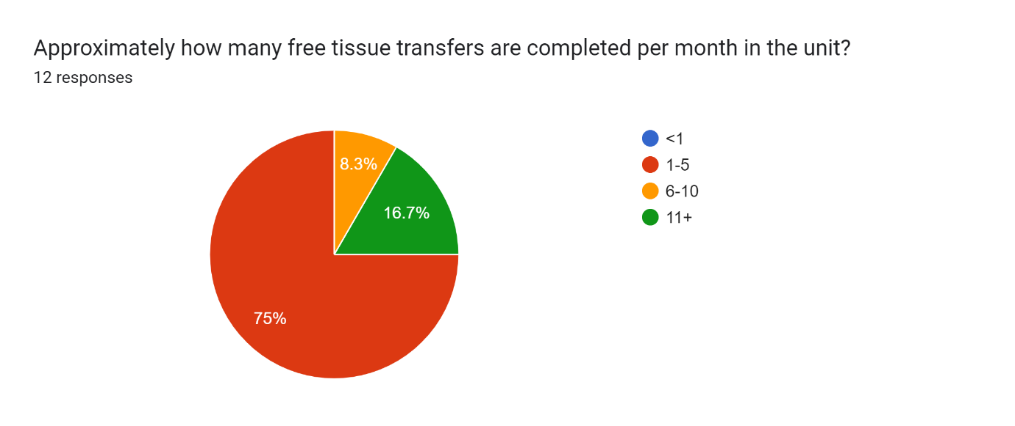
Figure 1: Approximation of how many free tissue transfers are completed each month in the OMFS units included in the survey.

The majority of units, 75%, had a written protocol for free tissue transfer monitoring, however only 58.3% of units had a proforma to complete when undertaking free tissue transfer monitoring.

When looking at who undertakes the regular monitoring of free tissue transfers in the post-operative period this predominantly is carried out by the nursing teams and DCTs/SHOs within the unit. For half of the included units in this survey free tissue transfer monitoring was shared equally between the nursing team and DCTs/SHOs, for 25% of units it was predominantly the DCTs/SHOs undertaking the observations and for the remainder all regular monitoring was undertaken by the nursing team.

Variation was seen in the frequency of regular observations of the free tissue transfer, shown in Figure 2. Most units (92%) undertake hourly observations in the first 24 hours post-operatively, and two-thirds of units carried on with hourly observations on the second day post-op. For the third day post-op units varied between hourly, 2-hourly and 4-hourly observations; by day four post-op over half of units are undertaking routine observations 4 hourly or less. By day 8, 75% of units were undertaking free tissue transfer monitoring twice daily or daily.

Figure 2: Frequency of routine monitoring of free tissue transfers post-operatively.

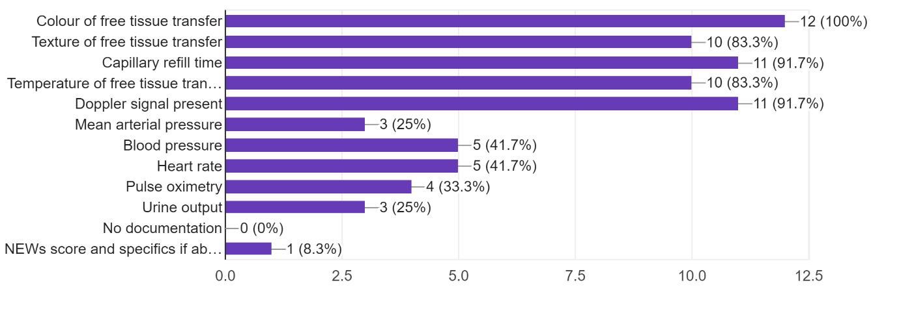
Data was collected on what observations were recorded when monitoring the free tissue transfers at both ward round, Figure 3, and any further routine monitoring undertaken throughout the day, Figure 4. At ward round all units were recording the colour of the free tissue transfer, with the majority also recording capillary refill time and if a Doppler signal was present (91.7%), most units also recorded texture and temperature of the free tissue transfer (83.1%).
Figure 3: Post-operatively: monitoring during ward rounds. Responders were requested to tick all observations that are routinely documented on their proforma or in the notes (if no proforma) during ward round when reviewing a free tissue transfer.

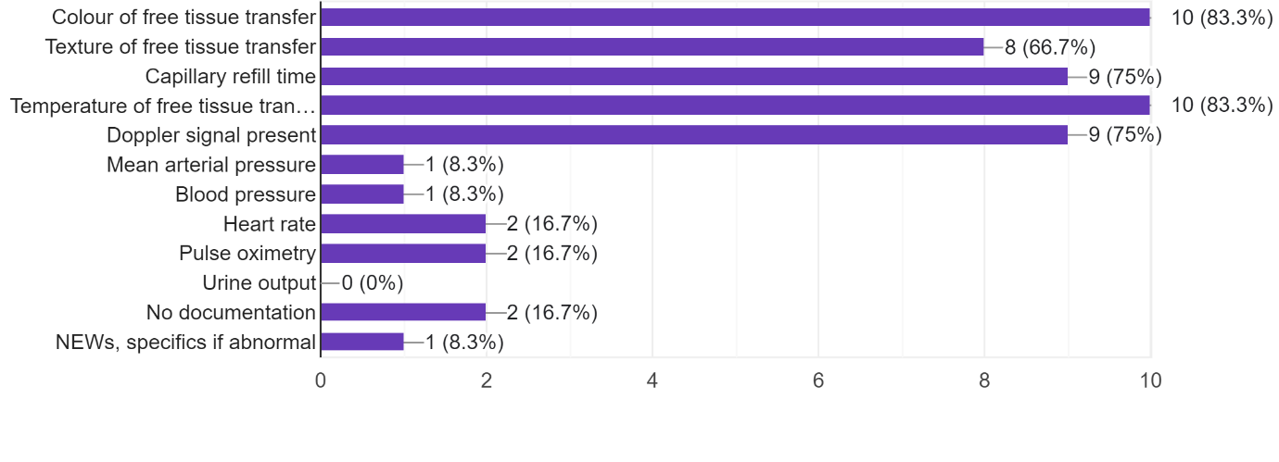
For further routine reviews throughout the day, Figure 4, 2 units did not document the reviews, however the majority continued to document colour, texture, temperature, capillary refill time of the free tissue transfer as well as a Doppler signal being present.
Figure 4: Post-operatively: additional routine monitoring outside of ward rounds. Responders were requested to tick all observations that are routinely documented on their proforma or in the notes (if no proforma) during each routine review of a free tissue transfer.

A further question related to the use of a Doppler – whether an implantable Doppler, hand-held Doppler or no Doppler is routinely used within the unit, Figure 5. One unit did not use a Doppler to routinely monitor in the post-operative period, one unit used both type of Doppler’s , with the remainder using either an implantable or hand-held Doppler, with the implantable Doppler being used more frequently.

Figure 5: Use of Doppler to monitor post-operatively.

A final question was asked in relation to frequency of consultant review post-operatively on the ward, this was a free text answer, Figure 6. Predominantly consultants in most units are reviewing the free tissue transfer daily in the post-operative period.
Figure 6: Free text responses relating to frequency of consultant review of the free tissue transfer post-operatively.
Daily Unsure Daily for first 48hrs but variable Daily
Daily Daily Twice daily Twice a day to daily depending on consultant
At the review appointment only Usually 2xdaily for first 5-7 days Daily
Usually checked by StR - Consultant will check if they attend WR (daily or 3-4 times weekly)

Discussion:
This survey has allowed data to be collated on the current practice in 12 of the OMFS units in England and Wales undertaking free tissue transfers for reconstruction of head and neck defects; although this project does not include all UK units it gives a snapshot of current practice.

A systematic review undertaken by plastic surgery colleagues looking at free tissue transfers concluded monitoring is most crucial for flap salvage in the first 48 hours post-operatively ^{[7]}, this was in keeping with the findings in this survey with all units undertaking routine free tissue transfer monitoring either hourly or 2-hourly for the first 48 hours. The systematic review also found that no flaps were successfully salvaged beyond day 4 post-operatively^{[7]}, questioning the need for continued frequent free tissue transfer monitoring. A study looking at the patient’s perceptions of free tissue transfer monitoring found the reduction of observations from hourly to 4-hourly came as a relief to over 50% of patients and 45% would have preferred observations to be less frequent through the night^{[8]}.

A difference was also noted between units regarding who was predominantly undertaking monitoring of the free tissue transfer with some units this being solely the responsibility of the nursing team and others solely the responsibility of DCTs/SHOs, for half of units this was shared equally often with checks being alternated by the nursing team and DCTs/SHOs. It has been noted in several studies from America that monitoring of free tissue transfers by appropriately trained nursing staff does not adversely affect the outcome of free tissue transfer success^{[9, 10]}.

It is challenging to find literature on what post-operatively free tissue transfer monitoring should include. Frequently included domains are free tissue transfer colour, temperature, capillary refill time and Doppler assessment^{[11, 12, 13]}, in keeping with the results of this survey.

There are several limitations to this survey, one being it does not include all UK units, a further being that it is only an insight into monitoring protocols with no data collection in relation to outcomes – success, return to theatre for salvage or failure rates. It would be challenging in this format to collect data of this nature to draw any meaningful conclusions. Further detailed data collection would be required from each unit in relation to when a flap was identified as requiring a return to theatre, outcomes of this as well as patient demographics and further details relating to the free tissue transfer.

A further limitation relates to each response relying on the individual in that unit completing the survey being aware of the unit’s policies for free tissue transfer monitoring. It also proved challenging to obtain completed survey results, hence the limited number of responses.

Conclusion:
This survey highlights the variation in clinical practice of free tissue transfer monitoring in 12 OMFS units in England and Wales. Variation exists in who undertakes the observations and how frequently, as well as the presence of a written protocol to follow and proformas to complete. The majority of units are documenting colour, texture, temperature, capillary refill time of the free tissue transfer as well as Doppler signal being present at each routine monitoring observation.

References:
- Wang KY, Lin YS, Chen LW, Yang KC, Huang WC, Liu WC. Risk of Free Flap Failure in Head and Neck Reconstruction: Analysis of 21,548 Cases From A Nationwide Database. Ann Plast Surg. 2020 Jan;84(1S Suppl 1):S3-S6. doi: 10.1097/SAP.0000000000002180. PMID: 31833882.
- Copelli C, Tewfik K, Cassano L, Pederneschi N, Catanzaro S, Manfuso A, Cocchi R. Management of free flap failure in head and neck surgery. Acta Otorhinolaryngol Ital. 2017 Oct;37(5):387-392. doi: 10.14639/0392-100X-1376. PMID: 29165433; PMCID: PMC5720866.
- Lovětínská V, Sukop A, Klein L, Brandejsová A. FREE-FLAP MONITORING: REVIEW AND CLINICAL APPROACH. Acta Chir Plast. 2020 Winter;61(1-4):16-23. English. PMID: 32380838.
- van Gijn DR, D'Souza J, King W, Bater M. Free Flap Head and Neck Reconstruction with an Emphasis on Postoperative Care. Facial Plast Surg. 2018 Dec;34(6):597-604. doi: 10.1055/s-0038-1676076. Epub 2018 Dec 28. PMID: 30593075.
- Novakovic D, Patel RS, Goldstein DP, Gullane PJ. Salvage of failed free flaps used in head and neck reconstruction. Head Neck Oncol. 2009 Aug 21;1:33. doi: 10.1186/1758-3284-1-33. PMID: 19698095; PMCID: PMC2749848.
- Whitaker IS, Gulati V, Ross GL, Menon A, Ong TK. Variations in the postoperative management of free tissue transfers to the head and neck in the United Kingdom. Br J Oral Maxillofac Surg. 2007 Jan;45(1):16-8. doi: 10.1016/j.bjoms.2005.11.021. Epub 2006 Jan 24. PMID: 16439041.
- Shen AY, Lonie S, Lim K, Farthing H, Hunter-Smith DJ, Rozen WM. Free Flap Monitoring, Salvage, and Failure Timing: A Systematic Review. J Reconstr Microsurg. 2021 Mar;37(3):300-308. doi: 10.1055/s-0040-1722182. Epub 2021 Jan 4. PMID: 33395711.
- Nazir H, Lowe D, Rogers SN. Patients' experience of the monitoring of free flaps after reconstruction for oral cancer. Br J Oral Maxillofac Surg. 2017 Dec;55(10):1008-1012. doi: 10.1016/j.bjoms.2017.10.005. Epub 2017 Nov 8. PMID: 29128255.
- Shen AY, Lonie S, Lim K, Farthing H, Hunter-Smith DJ, Rozen WM. Free Flap Monitoring, Salvage, and Failure Timing: A Systematic Review. J Reconstr Microsurg. 2021 Mar;37(3):300-308. doi: 10.1055/s-0040-1722182. Epub 2021 Jan 4. PMID: 33395711.
- Jackson RS, Walker RJ, Varvares MA, Odell MJ. Postoperative monitoring in free tissue transfer patients: effective use of nursing and resident staff. Otolaryngol Head Neck Surg. 2009 Nov;141(5):621-5. doi: 10.1016/j.otohns.2009.07.008. Epub 2009 Sep 6. PMID: 19861201.
- Abouyared M, Katz AP, Ein L, Ketner J, Sargi Z, Nicolli E, Leibowitz JM. Controversies in free tissue transfer for head and neck cancer: A review of the literature. Head Neck. 2019 Sep;41(9):3457-3463. doi: 10.1002/hed.25853. Epub 2019 Jul 9. PMID: 31286627.
- Kruse AL, Luebbers HT, Grätz KW, Obwegeser JA. Free flap monitoring protocol. J Craniofac Surg. 2010 Jul;21(4):1262-3. doi: 10.1097/SCS.0b013e3181e1e6e9. PMID: 20613605.
- Whitaker IS, Gulati V, Ross GL, Menon A, Ong TK. Variations in the postoperative management of free tissue transfers to the head and neck in the United Kingdom. Br J Oral Maxillofac Surg. 2007 Jan;45(1):16-8. doi: 10.1016/j.bjoms.2005.11.021. Epub 2006 Jan 24. PMID: 16439041.
Appendix 1: Free Tissue Transfer Monitoring Protocols in UK OMFS Units Google Form:

Thank you for taking the time to complete this short survey. Completion should take no longer than 5 minutes. Data collected will be kept anonymized and 'Name of OMFS Unit' is purely being used so that only one response per unit is included. Thank you.

- Name of OMFS Unit:_______________________
- Grade of individual completing survey:
DCT CT StR Consultant Other (please specify)
- Approximately how many free tissue transfers are completed per month in the unit?
<1 1-5 6-10 11+
Post-operatively:
- Do you have a written protocol for free tissue transfer monitoring ?
Yes No
- Do you have a proforma to complete when undertaking free tissue transfer monitoring?
Yes No
- Who predominantly undertakes free tissue transfer monitoring?
    - Nursing staff
    - DCTs/SHOs
    - StR
    - Shared equally between nursing team and DCTs/SHOs
    - Other (please specify):__________________________
- Routinely is a Doppler used to monitor?
- Implantable Doppler
- Hand-held Doppler
- No Doppler
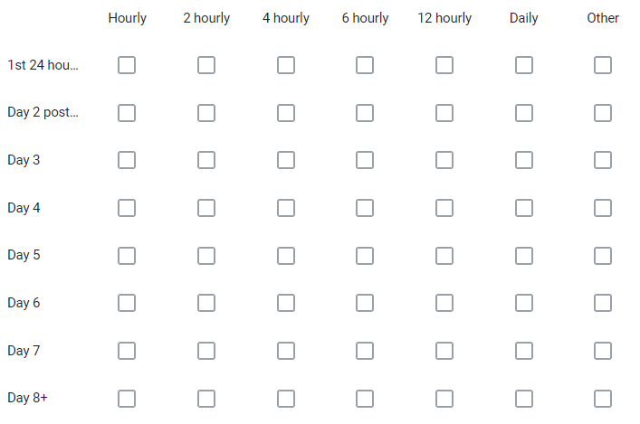
- How frequently are monitoring observations undertaken routinely?
- Monitoring during ward rounds – Please tick all observations that are routinely documented on your proforma or in the notes (if no proforma) during ward round when reviewing a free tissue transfer:
- Colour of free tissue transfer
- Texture of free tissue transfer
- Capillary refill time
- Temperature of free tissue transfer
- Doppler signal present
- Mean arterial pressure
- Blood pressure
- Heart rate
- Pulse oximetry
- Urine output
- No documentation
- Other
- Additional monitoring outside of ward rounds – Please tick all observations that are routinely documented on your proforma or in the notes (if no proforma) during each routine review of the free tissue transfer:
- Colour of free tissue transfer
- Texture of free tissue transfer
- Capillary refill time
- Temperature of free tissue transfer
- Doppler signal present
- Mean arterial pressure
- Blood pressure
- Heart rate
- Pulse oximetry
- Urine output
- No documentation
- Other
- Frequency of free tissue transfer review by an OMFS consultant?____________________

