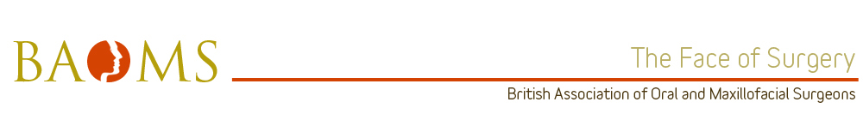
BAOMS Trainer of the Year nomination: David Sutton
Health Education Yorkshire and Humber

Leadership
David Sutton qualified in OMFS from the Mersey Deanery in 2003. The majority of his work involves Head and Neck Oncology however he will take charge and lead our team in all aspects of OMFS that inevitably present to a teaching hospital. Busy on-take periods with Mr Sutton are a mixture of teaching, instruction and step-by-step guidance of ‘how to do it”. All of this is delivered with good humor and professionalism.
Communication
Mr Sutton is not only a trained teacher of OMFS but he is an expert career coach in surgery. He has a relaxed style of communication that puts trainees at ease yet encourages them to progress and reflect on their performance under his guidance.

Training and Development
Head and Neck Oncology is shared with trainees so that they can get the most out of time in theatre, clinics and the wards. Theatre sessions see Mr Sutton advise, assist and guide trainees (of all levels) through procedures with seemingly endless patience. He naturally knows when to stand back and when to offer instruction. He knows where and when you need to succeed and devises strategies to build confidence yet ensure you meet the required surgical standard.

Resourcefulness
Due to the nature of our training program, Mr Sutton is not always to be found with a keen surgical protégé in attendance. However, if you are lucky enough to be rotated into his team, regardless of the procedure, Mr Sutton will always allow his trainee to deliver the final cut and congratulate them on their success. His control and management are such that he has no need to take over and limit those under his training.
Microsurgery is a weekly aspect of Mr Sutton’s practice. Under his training this is not a ‘consultant only’ procedure. His generosity in supervising registrars in this aspect of our speciality hints at his expert skills in training and knowing exactly the right time to push trainees so they can get the maximum benefit from their shared time together.
This expertise in both surgery and training is why we hold Mr Sutton in such high regard and feel he should be recognised for his service to OMFS.

