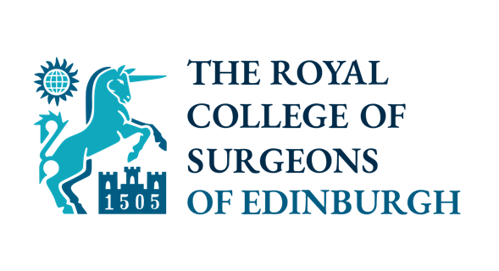


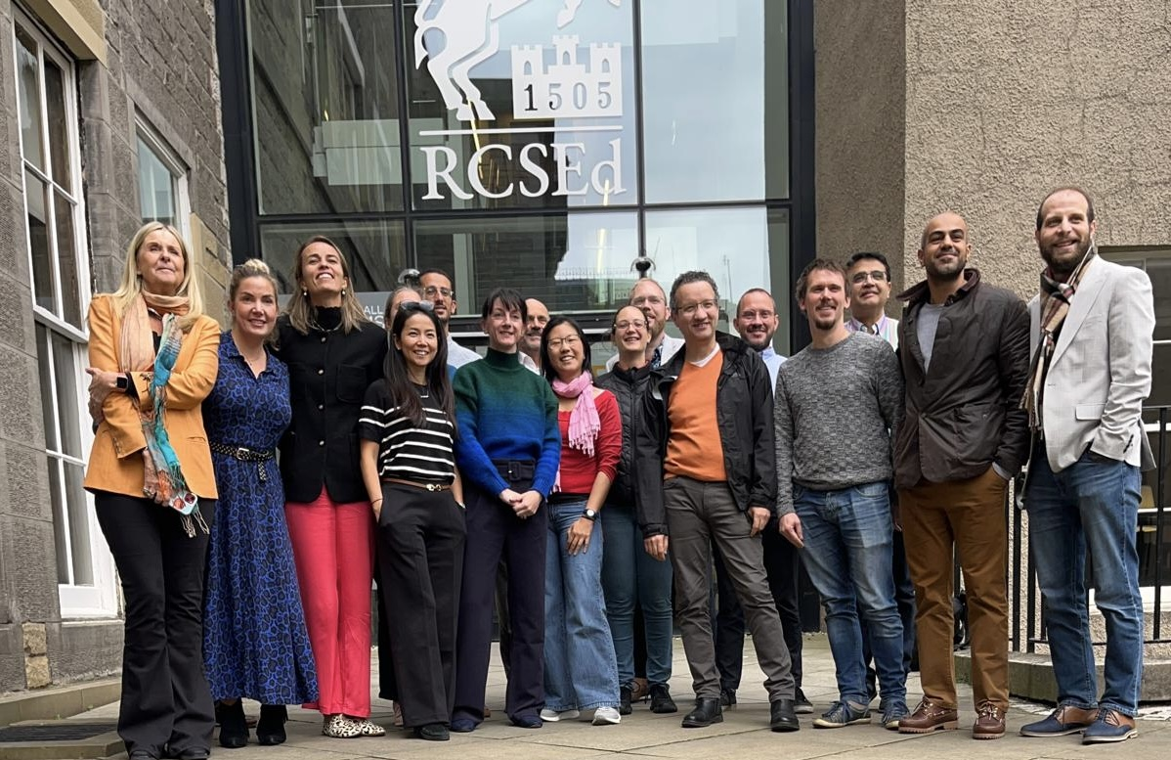

The Future Leaders Programme (FLP) is open to OMF surgeons, alongside general surgeons, ENT, urology, breast, vascular, cardiothoracic, paediatric and plastic surgeons. The programme is accredited by the Royal College of Surgeons of Edinburgh (RCSEd) and funding is available from BAOMS, specifically for an OMF surgeon.

FLP is a 12-month blended learning programme supporting ST8, SAS and those in the first years of consultancy with the passion to be future leaders within OMFS and equip them with the advanced leadership skills needed to excel.

Participants will complete an educational project to provide a vehicle for learning and developing leadership skills. We are delighted to invite applications for the fifth cohort here. Applications will close on 29th May

We will cover the £ 3960 fee; you would be expected to meet the £200 admin fee for the RCSed and your own travel and accommodation costs.

Previous BAOMS-funded participants include:

2022/2023 – Saadia Farooq - Glasgow
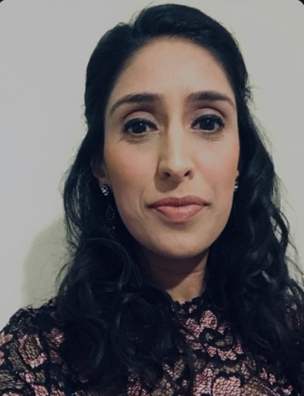
I have found it extremely beneficial. The course itself comprises of a combination of both online and face to face teaching and an opportunity to lead an educational project. My project idea related to providing OMFS StR’s in the early years of training with a microvascular model to be able to use for simulated PBAs to help them develop these competencies early on in training. Whilst this project is in its early stages, the programme is more about developing skills to be able to lead projects and use these skills for future project such as identifying stakeholders and finding ways to gain their support.
Whilst there are a number of leadership and management courses available, I feel that this particular programme is a great one for OMFS consultants in their early years or senior OMFS trainees about to embark on consultancy. I had previously undertaken a PG Cert in Medical education but didn’t really know how to use the theory I had gained in practice. The future leaders programme uses some of the key elements of educational theories that we will need as trainers of the future and helps to put theory into practice. It has taught me ways to lead seminars, tips and tricks for presentations, team building, and networking with other specialties. In addition, the programme has also taught me how to set up my ISCP as a trainer and make that transition from trainee to trainer. Both Lisa and Humphrey are great teachers and both very approachable and their years of experience are invaluable.
I have thoroughly enjoyed meeting the other delegates on the programme who are from many different surgical specialties and sharing ideas about my educational project with these individuals has helped tremendously in deciding what might work and what may not work. In addition, they will be friends and colleagues of the future. I feel it is important that OMFS as a specialty is represented annually on this programme as I have certainly felt it has been beneficial so far.

2023/2024 - Eiling Wu - Glasgow
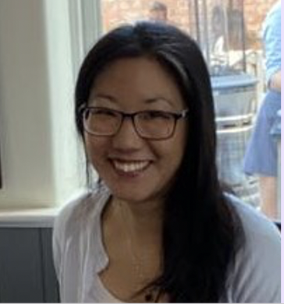

Eiling’s project focused on how helping resident doctors learn how to safely assess and treat OMFS patients

2024/2025 - Takaaki Sato - Manchester

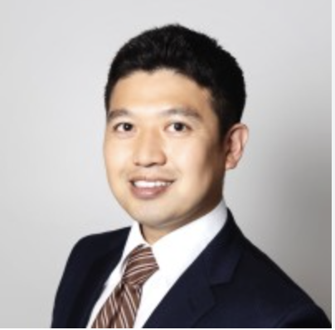

Taka’s project aims to develop Entrustable Professional Activities (EPAs) for a one-year fellowship in head and neck reconstructive microsurgery. Despite the growing global emphasis on competency-based training, no current fellowship programme in this field is structured around EPAs. In collaboration with international experts, this project will establish EPAs to provide a clear, progressive framework toward independent surgical practice.

The EPA concept originated in the Netherlands and later spread to North America. While similar to the UK’s Capabilities in Practice (CiPs), EPAs tend to be more specific and task-focused.

Taka is halfway through the FLP programme

