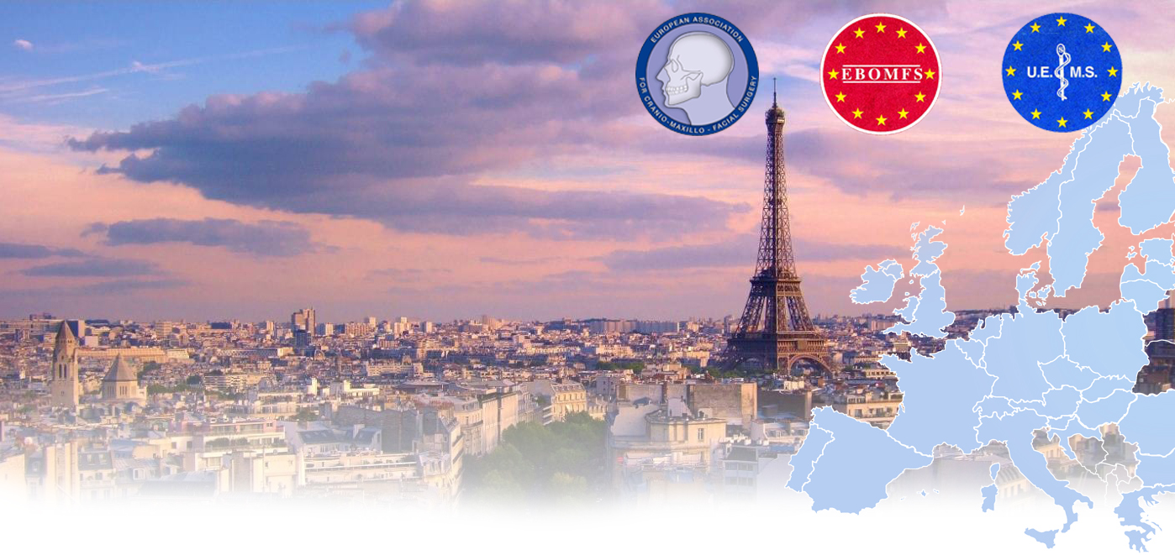

**13th Assessment of the**

**European Board in**

**Oro-Maxillo-Facial Surgery (EBOMFS)**

13 – 14 September 2020

Paris

**CONTACT AND INFORMATIONS:**

**European Board of Oro-Maxillo-Facial Surgery**

(EBOMFS)

[www.ebomfs.eu](http://www.ebomfs.eu)

**President President Scientific Committee**

Dr. Blaise Kovacs Dr. Dr. Henri Thuau

Belgium Switzerland

**General Secretary Honorary Chairman**

Prof. Risto Kontio Prof. Carlos Navarro Vila

Finland Spain

**www.ebomfs.eu**

**Application Requirements:**

* Medical Specialist title in Oro-Maxillo-Facial Surgery recognised in one of the European countries
* All relevant documentation (CV, logbook) to be sent via email.

**Fees:**

The fees for the two-day Assessment amount to 480 € (payable to the European Board of Oro-Maxillo-Facial Surgery).

**Venue:**

25th Congress of the European Association for Cranio-Maxillo-Facial Surgery (https://www.emma.events/eacmfs2020/welcome)

15th-18th September 2020

Palais des Congrès de Paris

2 Place de la Porte Maillot

75017 Paris, France

**Registration:**

The online registration will be available as from January 2020.

**Deadline for Applications:**

May 31st 2020

www.ebomfs.eu

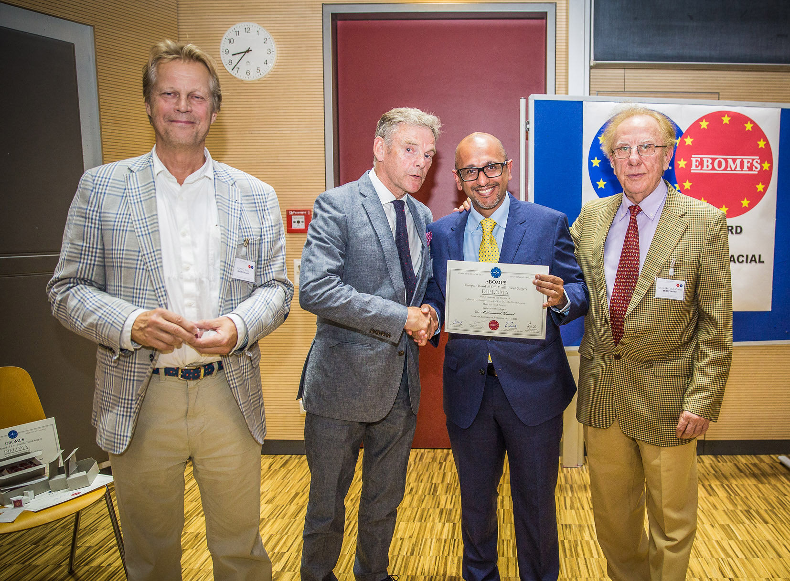

**Assessment process:**

The Assessment is composed of two parts:

* **Part I:** Curriculum vitae and surgical logbook: Academic titles, Publications, Thesis, Awards, Operations performed.
* **Part II:** Multiple Choice Questions Examination: covering the entire spectrum of Oro-Maxillo-Facial Surgery.

Oral Examination including case presentation: duration 45 minutes. 3 Examiners.

Languages: English, French, German, Spanish

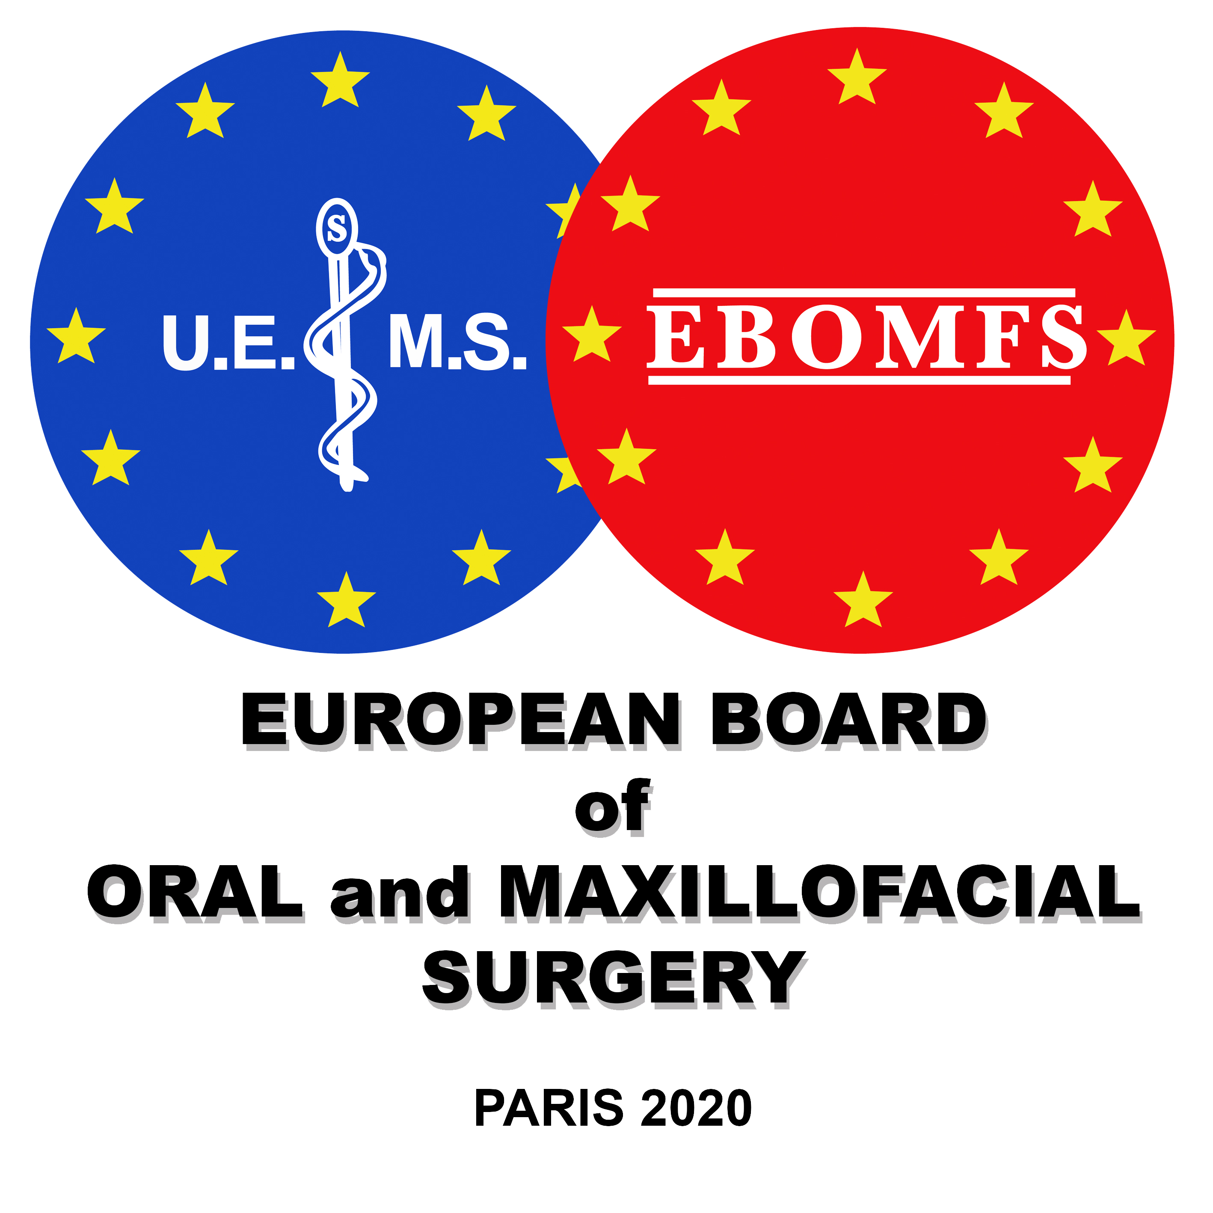

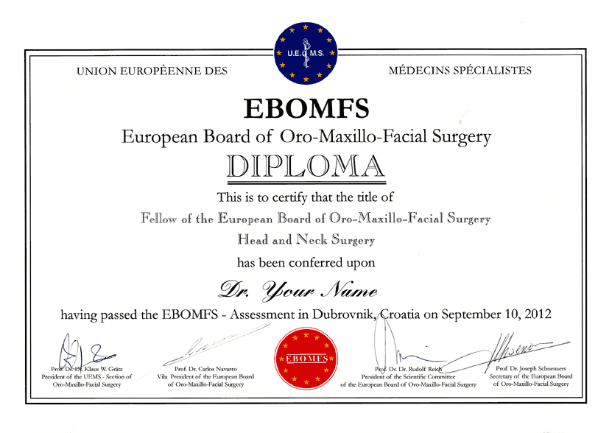

**Facts:**

* EBOMFS was established in 1996.
* More than 500 European successful candidates.
* Fellows of the EBOMFS from: Austria, Belgium, Croatia, Czech Republic, Finland, France, Germany, Greece, Hungary, Italy, the Netherlands, Portugal, Romania, Spain, Switzerland and the UK.

**Advantages of being a Fellow of the EBOMFS:**

* Personal development and competency enhancement.
* Internationally recognised Diploma.
* Renowned additional qualification.
* Opportunity for international networking.
* Benchmarking: belong to the best!

Dear Colleagues,

We are delighted to invite you to take part to our **European Board Assessment in Oro-Maxillo-Facial Surgery**, which will be held just before the 25th EACMFS Congress in Paris (13th-14th September 2020). The Assessment will be organised in the same venue as for the EACMFS Congress (Palais des Congrès de Paris) for more convenience. You will be given the opportunity to meet the key opinion leaders of our specialty, as well as join the ever growing number of EBOMFS Fellows. Do not miss this opportunity !

The European Board of Oro-Maxillo-Facial Surgery will deliver the Diplomas during a solemn ceremony on the 14th September.

We look forward to meeting you in Paris !