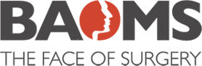
BAOMS STUDENT BURSARY 2022
ROXANNE MEHDIZADEH

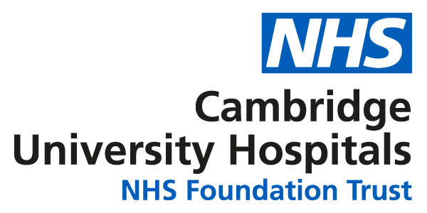

Introduction
Face Forward is a charitable partnership which was founded by Oral and Maxillo-Facial Surgery specialty trainee Shadi Basyuni, and OMFS consultant Mr Vijay Santhanam from the Addenbrooke’s hospital OMFS department, in conjunction with Cambridge Global Health Partnerships (CGHP). The project seeks to form a long-term, two-way partnership between the Addenbrookes-based OMFS team and the Jordanian surgeons working on the ground in Amman, by carrying out regular trips to Jordan to provide surgeries for the refugee population, which is estimated to be around 730,000 individuals, predominately from Syria, Iraq, Yemen, Sudan and Somalia¹. As well as carrying out the surgeries themselves, the project aims to establish virtual multidisciplinary team meetings, with collaborative teaching between teams both online and in-person during future trips, in addition to developing educational and research partnerships in the region.
Aims of the project
Throughout this second-degree bursary project report, I have detailed my involvement in this global health initiative throughout the past year. The aims of this project are twofold; first and foremost to be of service and benefit to the refugee population of Jordan, in keeping with the ethos of the Norman Rowe International Educational Foundation, which has sought to address the needs of individuals in developing and post-conflict countries. Secondly, the project aims to ensure the involvement of junior trainees and undergraduate students in the East of England with the Face Forward charity, to benefit from the learning opportunities presented.
The above aims were achieved by two key means. Throughout the past year, I have carried out remote work for the project, working to set up an electronic medical records system which can be accessed via a cloud system to allow for international collaborative working, in addition to carrying out fundraising efforts for the charity. Secondly, I attended the initial scoping mission in Amman during my medical school elective block, and have worked with CGHP to ensure the continued involvement of elective medical students in incoming years. It has been demonstrated that the elective period can greatly influence future career choice². Furthermore, studies have indicated that positive experiences during surgical rotations, including a welcoming theatre environment positively influences choice of surgery as a potential career in medical students³. Creating such constructive experiences during formative medical school years is therefore likely to ignite interest in students, with a potentially positive impact on recruitment and retention rates further down the line. This is particularly pertinent at a time when many OMFS specialty training rounds have been left with unfilled posts, raising concerns regarding the future of the speciality⁴.
Part 1: Development of the electronic medical records system
Previous OMFS charitable missions abroad within the department involved the use of a paper-based notes system. A key learning point which emerged was the value of using an electronic system, to facilitate the establishment of a long-term partnership. This is not only to allow effective record keeping at the time, but also to improve data capture for the purposes of audit and research. The charity aims to work with a clinical psychologist, to both provide psychological support for refugees, as well as to help determine the impact of the surgeries on their psychological wellbeing. Such questionnaires can be attached to the electronic patient record and subsequently analysed for research purposes, in order to help ascertain the effectiveness and impact of the interventions.
To this end, I contacted a software developer of an open resource electronic medical record system (Open EMR) with an interest in global health, who has worked with numerous charities in the past. I have worked with them throughout the year to design a platform suitable for the needs of the charity. This has involved modelling elements of our own hospital’s electronic patient record which have been effective in the day to day running of the department, which would also translate well for use in a global health setting.
An EMR encompassing the following features has been developed and will be implemented during the first trip:
- A secure EMR hosted on the hospital’s cloud system, allowing the remote access of patient records, facilitating international MDT discussions
- Enabling the creation of patient records, capturing basic data such as patient information, vitals, appointments, operating notes, laboratory results, prescriptions
- Allowing the upload of DICOM files for imaging to be viewed through the software
- A messaging system to allow patients to upload images and contact the operating team
- Enabling the upload of quality of life questionnaires and other outcome measures for the purposes of audit and research
- Allowing the operative procedures to be coded to determine estimated costs and expenditures during missions, to facilitate subsequent fundraising efforts

Part 2: Scoping trip to Amman, Jordan - June 2023
The purpose of the Face Forward scoping trip was to meet with stakeholders in Amman including the clinicians, hospitals and charitable partners to establish joint goals, identify the locations and resources that future surgical missions will involve and identify the patient groups who will receive treatment, as well as better understand the environment in which the work will take place.
During this visit, we met the CEO of Asia Development Training (ADT) – an organisation working to rehabilitate refugees who have suffered limb loss. We learnt about the work they carry out, with around 10 staff members treating around 200 patients each year. As well as physiotherapy, the charity runs art therapy sessions for children, and the paintings we saw were particularly poignant, highlighting the immense trauma the children had been through (figure 1). The team explained that unfortunately, most of the charitable funding they receive had been redirected towards efforts to help in the Ukraine war.
ADT offered to help us to identify future patients who will benefit from Oral and Maxillo-Facial surgeries, and a clinical psychologist working for the organisation will help with both the psychological support of the refugees, as well as the assessment of their psychological wellbeing, to determine the impact of the surgeries. These assessments can be attached to the patient’s electronic medical records, and subsequently analysed to determine the outcomes of the surgeries.
We also visited four hospitals in Amman (The Arab Medical Centre (figure 2), The Gardens Hospital, Abdali Hospital (figure 3) and Al Khalidi Hospital), and met numerous clinicians – both surgical and non-surgical - to better appreciate the socio-political context within which we will be working. They gave us a better insight into the Jordanian healthcare system and some of the attitudes towards the refugee population within the country. I was curious to get a sense of what the perception of refugees was in Jordan, considering the huge displacement of individuals into the country. We had a great conversation with a neurologist, who commented that they were not viewed as “other”, but as neighbours in need. He noted that prior to the refugee crisis, it was commonplace to spend a weekend in Damascus, renowned for its vibrant nightlife. Or to drive over to Beirut, often referred to as the ‘Paris of the Middle East’. Like many Jordanians, he had spent time studying in Iraq, owing to the comparatively low tuition fees. These sentiments were echoed by others we met when visiting hospitals and charitable organisations, and there was great enthusiasm and support surrounding the project.
It is estimated that 55% of the Jordanian population as a whole, and 68% of Jordanians, are covered by private health insurance⁵. Understanding the significant percentage of the local population unable to readily access medical care highlighted the need to broaden the mission. In Jordan, healthcare relating to cancer and trauma is covered for all Jordanians by the state, however other healthcare related expenses must be covered by the individual, either through insurance or upfront. Whilst free-at-point of care, state provided healthcare exists, the system is strained with capacity issues and it was unclear how and which patients can access this. The influx of around one million Syrian refugees has put pressure on the Jordanian healthcare system, in addition to its already growing population⁶.

Part 3: Fundraising and future work
Presently, we have raised half of our target of £15,000 required to fund the first mission⁷. Further fundraising efforts include plans to host an exhibition of the refugee children’s paintings from the Sir Bobby Charlton foundation. Furthermore, 10 members of the Addenbrooke’s Oral and Maxillofacial Surgery department plan to run the Cambridge half marathon in March to raise further funds for the first trip.
Following my medical elective, I shared my experiences at the CGHP medical electives talk, and have worked to establish the involvement of future medical elective students to join future trips with support from Cambridge Global Health Partnerships. As discussed, the continued involvement of medical students has been an important element of the project. This is particularly the case owing to the limited scope of exposure to OMFS within the medical school curriculum.

Conclusion
My involvement in Face Forward over the past year has greatly further fuelled my interest in the role of OMFS within global health. Previous experiences working with refugees volunteering on the dental vans in Camp Moria in Lesvos were formative as part of my initial motivations to return to study medicine. My time there made me further aware of the immensity of the refugee crisis, and the innumerable obstacles these individuals face – including access to adequate healthcare. It also deepened my understanding of the importance of creating sustainable projects, working with local partners where possible. I have therefore greatly appreciated the opportunity to be involved in a longer-term partnership, and hope to continue my work with the charity going forwards.
I was able to achieve my aim of creating a functioning EMR for the charity, in addition to contributing to fundraising for the first operating mission, and providing continuity for future medical students to join on medical electives, secondarily serving to improve exposure to the field of OMFS within the East of England. Furthermore, I had the opportunity to take part in the scoping mission, where we were able to achieve our aims of meeting all the key individuals and hospitals we had planned to visit. The in-person interaction is paramount to establishing trust, and determining common goals as well as how we aim to achieve them. We were met with great positivity and enthusiasm, and it was clear all the hospitals were well-versed in hosting such missions. We were also able to form links we had not anticipated, such as connections to the UNHCR and the British Ambassador, which may be beneficial in identifying patients for the surgeries. Overall, it has been a very positive experience, and I look forward to seeing how the project will take shape over the upcoming months and years.

Acknowledgements
With thanks to Shadi Basyuni and Mr Santhanam for kindly involving me in the project, in addition to CGHP for their support, and all the individuals who welcomed us with great enthusiasm during the scoping trip to Amman in June 2023.

References
- Jordan. UNHCR [cited Nov 2023]. Available from: https://www.unhcr.org/uk/countries/jordan
- Van den Broek WES, Wijnen-Meijer M, Ten Cate O, van Dijk M. Medical students' preparation for the transition to postgraduate training through final year elective rotations. GMS J Med Educ. 2017 Nov 15;34(5):Doc65. doi: 10.3205/zma001142. PMID: 29226233; PMCID: PMC5704611.
- Marshall DC, Salciccioli JD, Walton SJ, Pitkin J, Shalhoub J, Malietzis G. Medical student experience in surgery influences their career choices: a systematic review of the literature. J Surg Educ. 2015 May-Jun;72(3):438-45. doi: 10.1016/j.jsurg.2014.10.018. Epub 2014 Dec 24. PMID: 25544332.
- Al-Najjar Y, Rowe A, Naredla P, Magennis P, Smith AT. Three changes to reduce the loss of dual degree trainees from OMFS national specialty selection in the UK: evidence based proposals. Br J Oral Maxillofac Surg. 2022 Jan;60(1):36-41. doi: 10.1016/j.bjoms.2021.01.010. Epub 2021 Feb 1. PMID: 34284887.
- Liu M, Luo Z, Zhou D, et al. Determinants of health insurance ownership in Jordan: a cross-sectional study of population and family health survey 2017–2018. BMJ Open 2021;11:e038945. doi: 10.1136/bmjopen-2020-038945
- What’s next for Jordan’s Syrian refugees? Brussels International Centre. [cited Nov 2023]. Available from: https://www.bic-rhr.com/research/what-next-jordans-syrian-refugees#:~:text=Jordan%20has%20been%20a%20safe,found%20shelter%20in%20the%20country.
- Fundraising for FaceForward. JustGiving. [cited Nov 2023]. Available from: https://www.justgiving.com/fundraising/faceforwardjordan

Appendix 1: Photos from scoping trip to Amman, Jordan in June 2023
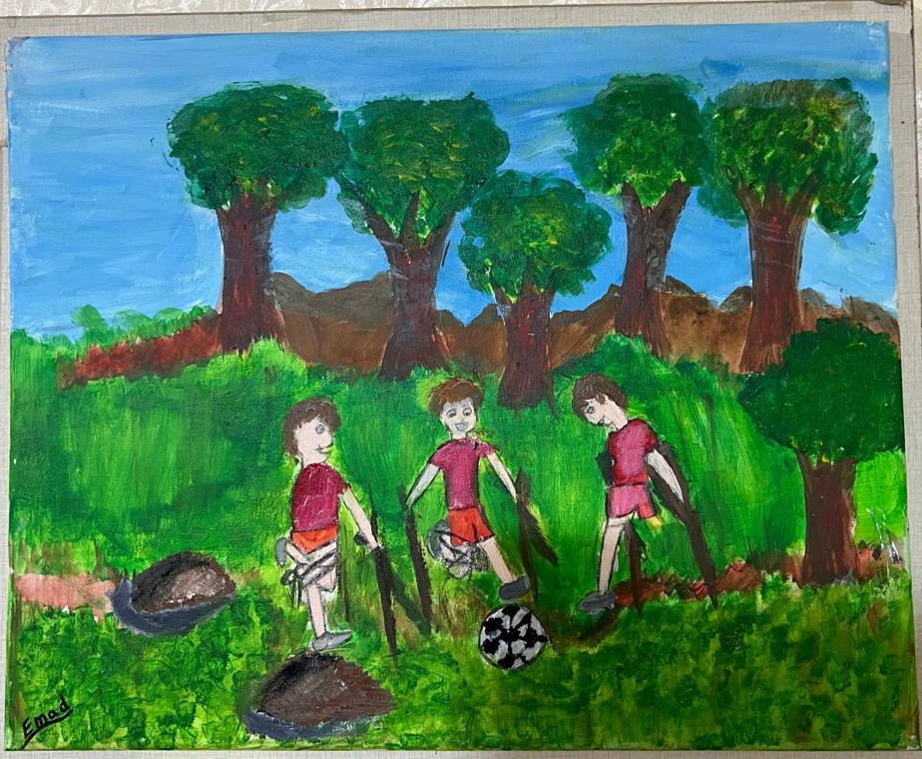
Figure 1: A painting by one of the children at the ADT charity, depicting three boys playing football. Two boys have tied up a leg to make the game fairer for their friend who has lost a limb in the conflicts.

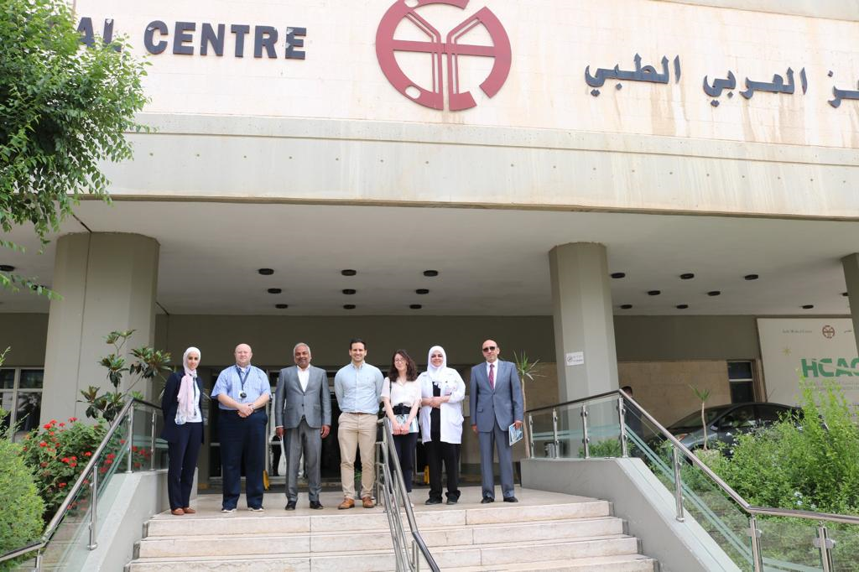

Figure 2: Outside the Arab Medical Centre with the Addenbrooke’s OMFS team and the local hospital staff.

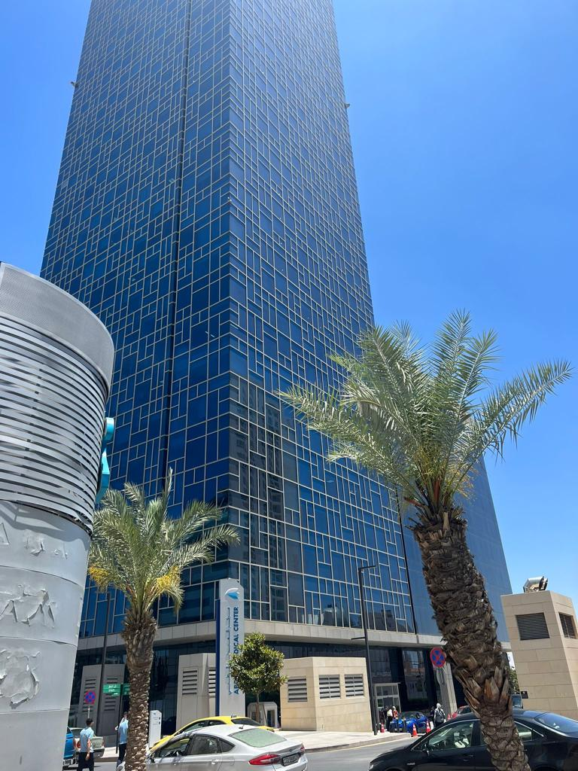

Figure 3: Abdali Hospital: a new build with modern facilities and a view of the King Abdullah Mosque from the theatre coffee room (as shown on page 1 of the report).

